**THE ANALYSIS OF THE MOVEMENT OF WILD TIGERS IN BETWEEN PATCHES**

**1Anannya Roy Chowdhury, 2Tanya Bansal, 3Saurabh Shanu**

1,2Department of Analytics, School of Computer Science and Engineering, University Of Petroleum and Energy Studies, Dehradun 248007, Uttarakhand, India.

3Department of Virtualization, School of Computer Science and Engineering, University of Petroleum and Energy Studies, Dehradun 248007, Uttarakhand, India**.**

**Abstract**

In this paper, we use Game Theory (Hawk and Dove game model), TPSMS (Territorial Predator Scent Marking Scheme), Graph Theory and Minimal panning Tree(kruskal algorithm) concepts to model, find mobility rate and distributional patterns, with tiger (*Panthera tigristigris)* as the focal species. We define metapopulation patches to examine the dynamics of the meta-population under each area. We find that the relationships between patch characteristics such as area, connectivity and the demographic processes of migrations vary among the different patch definition methods.

We construct a graph using the habitat patches substantiating wild tiger populations in the focal landscape patches as vertices and the possible paths between these patches (vertices) as edges. A matrix is constructed using the payoff to indicate the cost incurred by the tiger for passage between the habitat patches in the landscape.

**Keywords**: Metapopulation, TPSMS, Game theory, Graph theory, mobility rate.

1. **Introduction**

Dynamicity of metapopulation processes comprehend that the population of an area is under constant movement and is not a static concept in itself.

Wildlife corridors are integral components of ecological landscapes that facilitate the movement of organisms and processes between areas of intact habitat present in the landscape. This mobility of the anthropogenic species are recorded by a concept called Territorial Predator Scent Marking Scheme (TPSMS), also known as territorial marking or [spraying](https://en.wikipedia.org/wiki/Spraying_(animal_behavior)) which involves depositing strong-smelling substances contained in the [urine](https://en.wikipedia.org/wiki/Urine_spraying), feces, or, from specialized [scent glands](https://en.wikipedia.org/wiki/Scent_gland) located on various areas of the body and is used by animals to identify their territory.

1. **Patch Definition or Landscape Complex- The Central Indian Ghats(valley)**

The metapopulation approach provides a framework to model the population dynamics as a set of interconnected subpopulations (Hanski 1999) of the individual subdivisions of a large landscape complex. A landscape complex is a bio-geographical unit comprising contiguous ecological landscape patches (or at least minimally connected in the recent past), that have a potential for gene flow between the wild tiger populations (or other wildlife species) inhabiting the forests comprising the complex. Landscape deﬁnition is pivotal to the construction of the realistic metapopulation model, because it will determine patch size and connectivity, the latter being a function of the size and distance of neighboring patches.

The focal landscape complex of our paper is the Central Plateaus of India. The Central Highlands are a biogeographic region in [India](https://en.wikipedia.org/wiki/India) formed by the disjunct ranges of the [Satpura](https://en.wikipedia.org/wiki/Satpura) and [Vindhya Hills](https://en.wikipedia.org/wiki/Vindhya_Hills). It is given the term 6A within the Deccan zone in the Rodgers and Panwar (1988) classification. The zone adjoins 6D, the Central Plateau and 4B, the Gujarat Rajputana and extends across the states of [Maharashtra](https://en.wikipedia.org/wiki/Maharashtra), [Madhya Pradesh](https://en.wikipedia.org/wiki/Madhya_Pradesh), Bihar, Jharkhand, Chhattisgarh, Odisha, Andhra Pradesh, and Rajasthan.

The total area is approximately 250,000 km2 and there are 27 Protected Areas (20 Wildlife Sanctuaries and 7 National Parks) covering 4.9% of the area. There are also six [Project Tiger](https://en.wikipedia.org/wiki/Project_Tiger) Reserves in the region. Of this, roughly 40,837 km2 is under forest cover, with some of the country’s most famous tiger reserves and Protected Areas. This landscape supports 30 per cent of the world’s tiger population and 17 per cent of India’s tiger population with some of the largest contiguous forested tracks connected through wildlife corridors. Some of the tiger reserves critical from a conservation standpoint in this landscape are Kanha, Satpura, Pench, Melghat, Tadoba and Achanakmar.

At the turn of the 20th century, one estimate of the tiger [population](https://en.wikipedia.org/wiki/Population) in India placed the figure at 40,000, yet an Indian tiger census conducted in 2008 revealed the existence of only 1,411 tigers. 2010 tiger census revealed that there are 1700 tigers left in India.

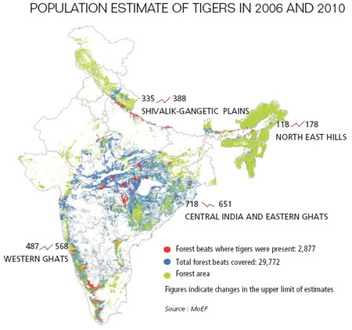

Fig. 1: A statistical representation of the forest and the tiger population in central Indian landscape.

As per the latest tiger census (2015), there are around 2226 tigers in India. By far, there is an overall 30% increase in tiger [population](https://en.wikipedia.org/wiki/Population). Various pressures in the later part of the 20th century led to the progressive decline of [wilderness](https://en.wikipedia.org/wiki/Wilderness) resulting in the disturbance of viable tiger [habitats](https://en.wikipedia.org/wiki/Habitat). The framework was then set up to formulate a project for tiger conservation with an [ecological](https://en.wikipedia.org/wiki/Ecology) approach. Despite the above factor which may be deemed detrimental to the health of regional biodiversity, the landscape complex, together with three Biosphere Reserves, is the largest tiger occupied area in India, and is home to the largest number of tigers in the country.

Also in this complex, various Tiger Conservation Units belonging to levels I, II and III have been identified for according priority status for conservation (Gopal et al. 2010; Jhala et al. 2008, 2011; Johnsingh and Goyal 2005).

**Modelling**

For the purpose of the present work, we assume that the wild tiger habitat patches in the landscape complex constitute the vertices and the collection of connections within these patches constitute the edges, comprising the focal landscape complex as a graph. The existence of an edge between any two vertices represents some population flux between the adjacent vertices.

An occupancy matrix is constructed using the ‘identity’ function of ARCGIS algorithm to indicate the cost incurred by the tiger for passage between the habitat patches in the landscape. Analysis of the graph is done using hawk and dove game theory algorithm, graph theory and minimum spanning tree (Kruskal) algorithm, in order to identify and focus on potentially important habitat patches, their potential community structure, and the possible movement patterns and the mobility rate of the tigers in between these patches.

Module 1: Setting up the grids over the focal landscape.

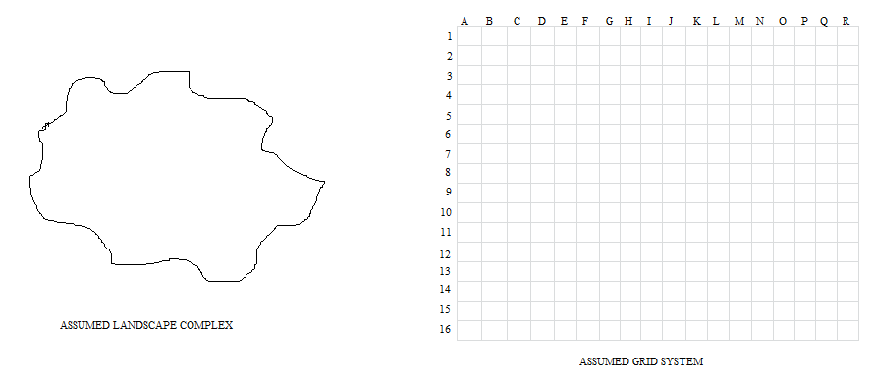

Fig 1: A diagrammatic representation of the landscape needs to be studied under the assumed grid.

Firstly a landscape has been assumed over which the grids need to be projected as represented in Figure 1. The grid distribution system is comprehended as latitudes and longitudes. Latitudinal rows are symbolized by numbers. Longitudinal columns are symbolized by alphabets. The focal landscape (preferably the central Indian landscape region) is then divided into smaller habitat patches by setting up the grid over the landscape as represented by Figure 2.

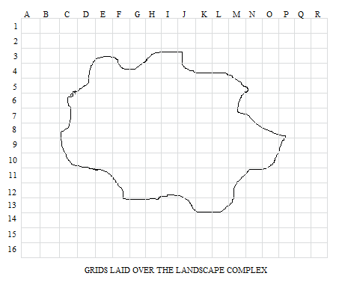

Fig.2: A diagrammatic representation of the set up landscape.

Module 2: Finding the complete and partial occupancy matrix.

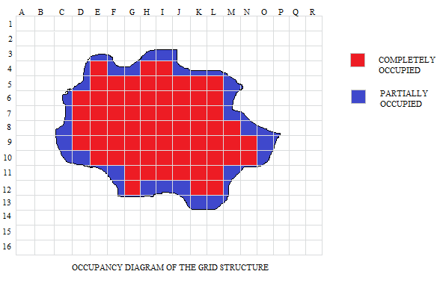

Fig 3. A diagrammatic representation of the landscape with the partial and maximum occupancy.

In Figure 3. We define the partial and complete occupancy of the landscape projected on the grids with their defined ids, if they lie inside the landscape. This has been done in order to obtain the correct membership of the various features and their contributions to calculate the score of a grid.

Module 3: Area occupancy matrix over the grid system.

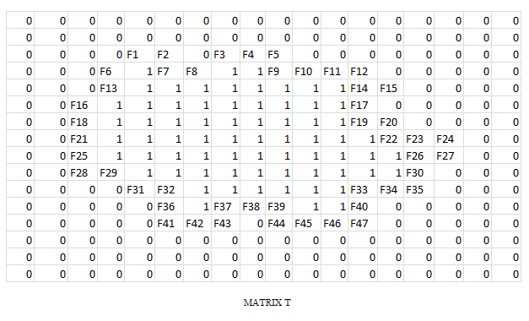

Fig. 4: A diagrammatic representation of the occupancy area of the matrix with their id.

For the section of the area which intersects between the grid system and the focal landscape complex, we calculate the fraction occupancy on the scale of one. This can be obtained using the “*identity”* function in ARCGIS. ARCGIS “identity” predicate is a default function required by all rasters in a mosaic dataset if there is no other suitable function. It is used to define the source raster as part of the default tiling behavior of the mosaic dataset and computes a geometric intersection of the input features and identity features. The input features or portions thereof that overlap identity features will get the attributes of those identity features.

The processing is done incrementally on subdivisions of the original landscape. Grids that straddle the edges of these subdivisions (also called tiles) are split at the edge of the tile and reassembled into a single grid during the processing. The vertices introduced at these tile edges will remain in the output features. Tile boundaries can be excluded in the output matrix when being processed.

The output of the algorithm will be an id coded matrix with labelling them:

* “0” for outside landscape
* “1” for inside the landscape
* “identity” for boundary of the landscape

For this module we use the following algorithm:

Algorithm Module_3 (L, G) where the input will be a 2D matrix of Grid and focal landscape.

Thus, for (i, j, k, l=0; i<n, j<m, k<p, l<q; i++,j++,k++,l++)

If (L[i][j] ! = G[k][l]) then put T[p][q] = 0

Else if (L[i][j] = G[k][l]) then put T[p][q] = 1

Else put T[p][q] = identity (L[i][j], G[k][l])

Module 4: Parameter/Decision Variables judgment for the given landscape.

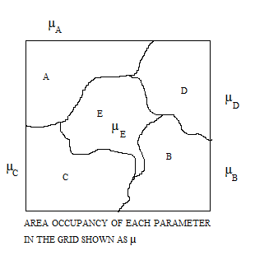

Fig. 5 A diagrammatic representation of the decision variables affecting the different areas within the landscape.

Decision variables are those parameters or the factors that elucidate the governing criteria for the persistence and the intensity of the supporting and demoting rationales of metapopulation strength for a region. The factors for each region may vary in a temporal manner and may range from the parameter brackets of habitat improvement, land acquisition, forest cover, prey base and other coordination activities.

We also check the area occupancy of each parameter in each and every grid. This is done by a linear programming model of the following constitution:

Algorithm Module_4 (T, A, B, C, D, E) where the input is a 2D matrix obtained in last module and output is 2D matrix of parameters in the focal landscape.

Thus, for (i, j = 0; i < n, j<m; i++, j++)

If (T[i][j] = 0), Pass it.

Else: A[i][j] = identity (T, A)

B[i][j] = identity (T, B)

C[i][j] = identity (T, C)

D[i][j] = identity (T, D)

E[i][j] = identity (T, E)

For our sample model we have considered the 5 different parameters: A, B, C, D and E and the area occupancy in each group obtained as the membership values for each parameter as the contribution in the total score of the grid.

Module 5: Payoff Calculation using the Evolutionary game model of Hawk and Dove.

The game model we intend to use is the Hawk and Dove Evolutionary game. The contestants can be either Hawk or Dove. These are two subtypes or morphs of one species with different strategies. The Hawk first displays aggression, then escalates into a fight until it either wins or is injured (loses). The Dove first displays aggression, but if faced with major escalation runs for safety. If not faced with such escalation, the Dove attempts to share the resource.

Let the Hawk and Dove game be represented by G and the pure strategies opt by the two decision makers called hawk (H) or dove (D). It is represented as:

G= {P, ∑, π},

Where {‘G’ is the set of the game theory, ‘P’ is the set of players, ‘∑’ is the set of strategies applied to play a game, ‘π’ is the set of the associated payoffs}.

We are using the concept of hawk and dove game theory because it gives a better payoff for the quantum games using a random strategy and maximum payoff for pure strategy. It uses both pareto optimality and nash equilibrium concept to maximize the payoff. It removes the local correlations where both the players are unaware of the fact that an entangled state has been distributed amongst them.

In our model, we need to classify the players acting as hawk or dove as these are two different types of the same species with different outlook and strategies.

Conditions of the game to be played as:

* Hawk being aggressive
* Dove trying to share the available resources.

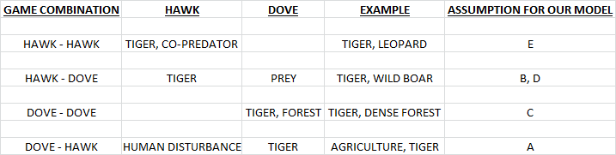

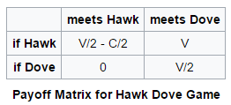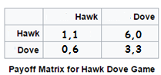

Fig. 6: A tabular representation of the hawk and dove game theory.

Algorithm Module_5 (T, A, B, C, D, E) where the input is the 2D matrix of Grid and updated parameters of focal Landscape

Here we are calculating the score for each grid by:

S[i][j] = ∑∑T[i][j]*Parameter[i][j]* (payoff).

Where {S[i][j] is the score of the respective grid }

Module 6: Ranking of the grids and Color Coding the cluster of rankings.

The ranking of the grids can be done in various ways, based on our suitability, like:

1. On the basis of class size.
2. On the basis of Centrality measures.
3. On the basis of ground data.
4. On the basis of any pre dominant factor, etc.

Here preferably we go through the Centrality measures and out of the present 288 grids for our model we rank them based on their respective scores and then dividing it into broad 10 categories decide the color code as given in Figure 7.

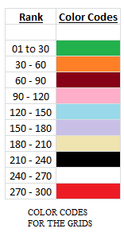

Fig. 7: A diagrammatic representation of the color codes for patches of the original land scape and the rank matrix of each color.

Flood fill [algorithm](https://en.wikipedia.org/wiki/Algorithm) determines the area [connected](https://en.wikipedia.org/wiki/Glossary_of_graph_theory#Connectivity) to a given node in a multi-dimensional [array](https://en.wikipedia.org/wiki/Array_data_structure). It is used in the "bucket" fill tool to fill connected, similarly-colored areas with a different color for determining which pieces are distinguishable.  The algorithm looks for all nodes in the array that are connected to the start node by a path of the target color and changes them to the replacement color. Thereafter ranking of the grids are done on the basis of the color fill as shown in Figure 7. Based on the above color codes we run our following algorithm and then process the codes in our sample.

Algorithm Module_6 (S) where the input is the score of the grid calculated from payoff matrix.

Here we are coloring the grid: n and m are the rows and columns of S respectively and z is the centrality index.

Thus, for (i = 0, j=0; i < n, j<m; i++, j++)

t = max (S[i][j]) and r = min (S[i][j]) and sample = (t – r) / z

For (i = 0, j=0, k=0; i < n, j<m, k=t; i++, j++)

R[i][j] = count (sample multiplication)

For (i = 0, j=0, k=0; i < n, j<m, k=t; i++,j++)

R[i][j] = color_fill (sample multiplication)

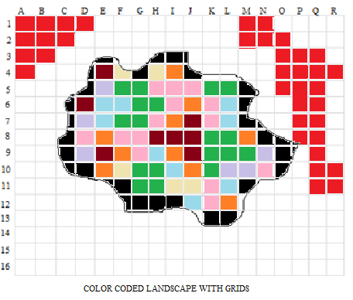

Fig. 7: A diagrammatic representation of the color coded patches of the original land scape.

Module 7: Designing an Algorithm to identify habitat patches within the landscape.

The habitat patches in the focal landscape will be found out using the following algorithm:

Algorithm Module_7 (R, z, a, b) where the input is the 2D matrix R.

Here grids are being colored where n and m are the number of rows and columns of R respectively and z is the best ranked grid color.

R[a][b] = position of first z

If R[a][b] = partial grid then STOP and START NEW SEARCH FOR z

If R[a][b] = 1 then Record = R[a][b]

Module_7 (R, z, a+1, b)

Module_7 (R, z, a, b+1)

Module_7 (R, z, a-1, b+1)

Module_7 (R, z, a+1, b-1)

Module_7 (R, z, a+1, b+1)

Module_7 (R, z, a-1, b-1)

Module_7 (R, z, a-1, b)

Module_7 (R, z, a, b-1)

Module 8: Connectivity optimization based on results of Module 5, Module 6 and Module 7.

Algorithm Module_8 (R, z, a, b) where the input is the 2D color coded matrix of R and output is a Minimum weighted graph with color coded patches in R and selected path.

MST-KRUSKAL(R, z)

AV← Ø

For each vertex v ­ V[R] do MAKE-SET (v), sort edges of E into increasing order by weight w

For each edge (u, v) ­ E, taken in increasing order by weight

If FIND-SET (u) ≠ FIND-SET(v)

Then AV← AV­ {(u, v)}

UNION (u, v)

1. **Conclusion**

**// sir we need to discuss on a few points regarding the topic and also do we need to add the present framework, work dynamics, sustainability of our project, our project logistics and feasibility and our project recommendation?**